**Practical 9**

|  |  |
| --- | --- |
| Roll No. A016 | Name: Varun Khadayate |
| Program: B-Tech (CSBS) | Division: SY |
| Batch: 1 | Date of Experiment: 28-02-2021 |
| Date of Submission: 20-03-2021 | Grade: |

Aim

Draw a deployment diagram for

1. Room Reservation
2. Online shopping system

Diagram

## Room Reservation

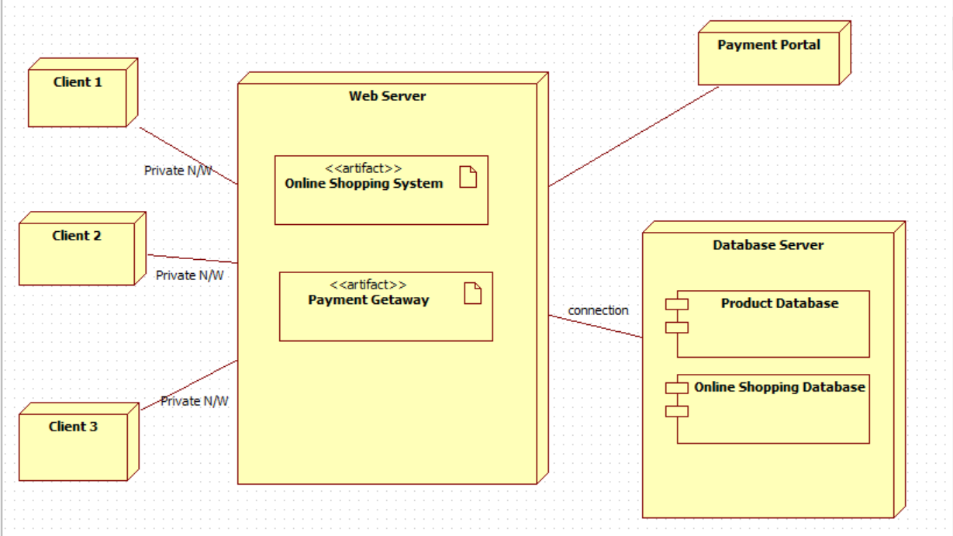

## Room Reservation System

